Brindishe Federation

Information Pack

Class Teacher September 2026
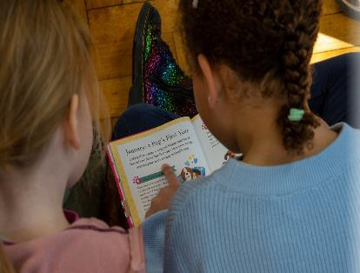



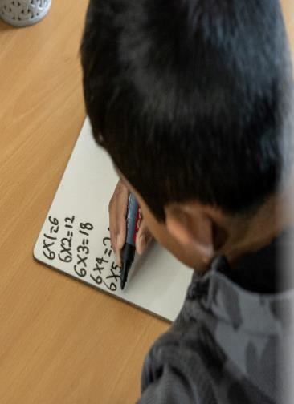



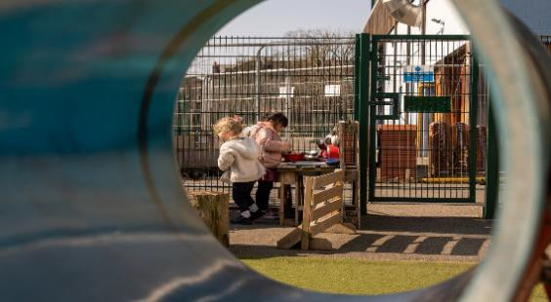

Brindishe Federation

Information Pack

Letter from Rachel Waite, Executive Head
Advert
Job Description Person Specification
Supporting the Application Process
Three Schools, One Community

Letter from Rachel Waite, Executive Head

Dear Candidate,

Post of Class Teacher within the Brindishe Federation

I am delighted that you have expressed an interest in the Class Teacher role within the Brindishe Federation. The Brindishe Schools are looking for passionate, motivated and committed individuals to join our thriving Federation.

Being so close together, the schools serve a local community based in the heart of Hither Green and Lee, South East London. The Brindishe Federation schools are strong, diverse, forward-looking and vibrant. Each school works closely within the Federation and has its own unique building. The staff value each other, the children and their families and we ensure that we do our very best for them. We have high expectations in terms of both learning and behaviour and our aim is for no child to be left behind.

Whether you are at the start of your career, or more experienced, this is a fantastic opportunity for you to join the Federation. We are looking for highly motivated teachers to join our creative, supportive and hard working team and to make a difference to the lives of our children and community.

Being part of the Federation allows each school to access a wealth of support including a very forward- thinking IT team, a highly skilled finance team and a motivated premises team. We can offer a wide range of training opportunities both within the Federation and also by external providers. This allows us to invest in our staff and develop them professionally as well as provide a fantastic education for our children.

I hope that by looking through the website and reading our information, you will be interested in applying for the post of class teacher. If you would like to visit the school, please email rufoster@brindisheschools.org (HR & Payroll Manager) or if you would like to have a conversation before applying, please email rawaite@brindisheschools.org or phone 07508 868726.


Kind regards,

Rachel

Rachel Waite
Executive Head

Are you passionate about making a difference for all children? Are you keen to work with a fantastic team of people?

We are seeking an inspirational teacher with vision and high expectations for learning to join our Federation. The successful candidate will have the opportunity to work with a highly skilled, supportive team of people committed to the staff, the children and the community.

The Brindishe Federation is made up of three Local Authority maintained schools within the borough of Lewisham, which are currently rated good and outstanding. Brindishe Lee, our one form entry school, is located in Lee. Brindishe Manor, a two form entry school and Brindishe Green, a three form entry school, both of which sit either side of Hither Green Station. All the schools are all located within 10 minutes of each other and are in walking distance of Hither Green or Lee mainline stations, just two stops from London Bridge, or a short bus ride from Lewisham DLR.

We are looking for a teacher who…
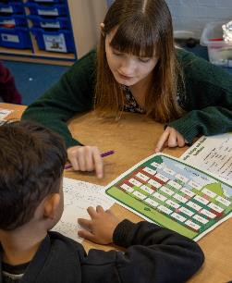
- values inclusion, creativity and the joy of learning and enrichment
- Is committed to promoting equity and diversity within our schools
- has a track record of raising achievement for all pupils
- can develop strong relationships with children, parents and the wider community
- can enthuse and engage
We can offer you…
- children with exceptional behaviours for learning
- a diverse and lively inner-London school community
- close partnerships and support within each school and across the Federation
- high quality and easily available resources for learning and a range of opportunities for those with a strong career pathway
- a bespoke training package for new and recently qualified teachers and leadership development for those with experience and ambition
- an ambitious, broad and progressive curriculum
- personalized and effective approach to planning, marking and assessment
- bright, well-maintained, clean, warm, well-equipped classrooms and adult workspaces
- trained and committed learning support assistants
- excellent business, technical, IT and admin support.

Above all you will have the freedom to teach creatively in line with our Brindishe Curriculum in a supportive environment. Please visit our website for details of each school www.brindisheschools.org
For an extended conversation please email our Executive Head, Rachel Waite, rawaite@brindisheschools.org or call
07508 868726. To arrange a visit please email rufoster@brindisheschools.org (HR & Payroll Manager)

Applications should be returned to our HR & Payroll Manager rufoster@brindisheschools.org
Closing Date Friday 15th May 2026 at 12.00pm. Only shortlisted candidates will be contacted.
Interviews to be held week commencing 18th May 2026
The Brindishe Federation is committed to safeguarding, equality and promoting the welfare of children and young people. We are also committed to having the highest expectations of pupil/students and staff and supporting everyone to reach their full potential. All employees of the Federation are expected to share these commitments. All posts require satisfactory employment checks and references and a satisfactory enhanced Disclosure and Barring Service check. All Leadership roles will require a Section 128 check.

The Application Process and Timetable

Application deadline: 12noon on Friday 15th May 2026 (only shortlisted candidates will then be called)
Interviews: Will take place during the week commencing Monday 18th May 2026

The interview will involve a short task, lesson observation and an interview

Brindishe Schools Job Description
Post: Class Teacher at Brindishe Schools
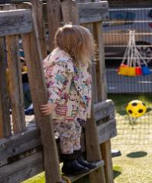
Salary: National Pay Scale at appropriate point (teaching and learning responsibility posts may be available for expertise and responsibility and will involve additions to this job description)

Reporting to: Headteacher / Executive Head
Period: Full time
Class teacher Job Description
- To take full responsibility for teaching a class of children, ensuring that all children make good and very good progress.

- To fulfil the requirements of the Conditions of Employment of School Teachers as outlined in the current School Teachers’ Pay and Conditions Document.

- To support, enhance, reflect and communicate the shared values and ethos of Brindishe Schools.

- To work in an inclusive, diverse setting using appropriate styles of organisation, classroom management and teaching and learning methodologies and to secure a rich and creative curriculum for all children.

- To support and promote the principles and practices of equality for all children and adults who are part of the school community.

- To know, adhere to and support the agreed policies and guidelines of Brindishe Schools and to support the effective implementation of the School Development Plans.

- To maintain an attractive, well displayed, well resourced, carefully organised and effective learning environment in the classroom and shared areas.

- To line manage and ensure the effective deployment of support staff attached to the class for whom the teacher has responsibility.

- To implement effective systems for evaluating, monitoring and securing raised levels of achievement including tracking and maintaining evidence of each child’s progress.

- To identify and plan for meeting the needs of all children including those with high ability, gifts and talents, learning and other special needs and those who are new to learning English.

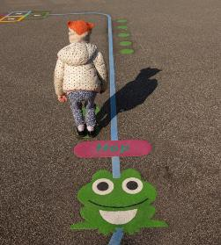
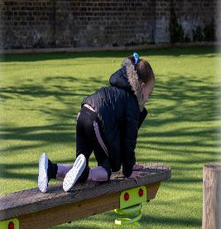
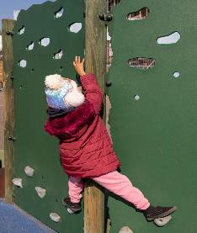
- Ability to provide evidence of the successful development of an area of expertise or specialism within and across a primary school including evidence of impact*.

* This criterion is only applicable if the candidate is seeking to secure a position of responsibility (TLR).

Brindishe Federation Person Specification
All post holders are expected to demonstrate a commitment to equal opportunities and a proven ability to work effectively in culturally and linguistically diverse classrooms

This person specification is related to the requirements of the post as determined by the job description. Shortlisting is carried out on the basis of how well you meet the requirements of the person specification and you should refer to these.

Description | Shortlisting
Right to work in the UK | Essential
Training & Qualifications
Qualified Teacher Status | Essential
Recent and relevant experience of teaching children in the Early Years/ KS1 or KS2 in a UK school setting | Essential
Successful Experience
Successful experience of teaching in two or more key stages | Essential
Proven record of raising standards for all pupils, including under achieving pupils | Essential
Experience of promoting positive behaviour conducive to learning, focused on raising standards | Essential
Knowledge and Understanding
Insight and understanding about the importance of an engaging, relevant and creative curriculum that inspires and motivates learners to make progress and achieve high standards | Essential
The knowledge and understanding of current theory and best practice in teaching and learning, particularly as this relates to high attainment and progress | Essential
Understanding of a diverse range of teaching and learning styles and techniques | Essential
Good understanding of the importance of culture and ethos and how this impacts on morale, high expectations and high standards | Essential
Good understanding of the role parents and the community in school improvement and how this can be practiced and developed | Essential
Clear understanding of data analysis and the important impact this can have on achievement and attainment | Essential
Characteristics and Competencies
Ability and willingness to promote the school’s aims and the positive culture and ethos | Essential
Ability to develop good personal relationships within a team; making an effective contribution to high morale | Essential
Highly effective communicator (oral and written) within and between teams and other stakeholders in the school community | Essential
Ability to create a happy, challenging and effective learning environment | Essential
Boundless enthusiasm, determination and drive to inspire others and achieve high standards | Essential
Self-motivated and resilient to the pressures of teaching and leadership | Essential
A solution-focused mind-set and determined ‘no-excuse’ approach to raising standards | Essential
A personable nature to build effective relationships with parents and all members of the school community | Essential
A lively, creative and good-humored approach to all aspects of teaching, management and leadership | Essential

Supporting the Application Process

Thank you for your interest in working at the Brindishe Federation. This Application guidance has been developed to help you to compete your application. Please take a few minutes to read through the information before filling out the application form.

THE APPLICATION

Your application will be your first point of contact with the Federation and the school you would like to work with. The content of your application will determine whether or not you will be invited to interview, therefore it is essential that you complete it as fully as possible. We will not make any assumptions about your abilities and do not take into account any previous applications.

CVs are not acceptable in the place of a completed application form and all candidates are required to address the criteria on the person specification.

- Personal Details: enter fully and clearly your name, address and telephone number(s) so that you can be easily contacted in the event that you are shortlisted to attend an interview.

- Employment State clearly your current or most recent employer’s name and address. Include details of the post held and (if applicable) reason for leaving.

- Previous Employment: enter names and addresses of all previous employers, starting with the most recent. You can also include work experience placements, holiday jobs or voluntary work in which you have developed skills relevant to the job you are applying for. It is very important that you complete this section in chronological order, and detail accurately any gaps between employment and other activities.

- Education: Provide full details of your education at secondary level and above along with details of degrees/diplomas and any other qualifications, including those that you are currently studying for. Make sure you give all the information required, including levels and grades of any examinations taken. If a required qualification has been specified for the role, make sure you give all the information required and levels of any examinations taken. You will be expected to provide documentary evidence if you are invited for an interview.

- Supporting Statement: this section is very important. It gives you the opportunity to detail why you feel you are the best person for the job and why you are applying, and is the key information that is used for shortlisting. Before completing this section refer to the Job Description and Person Specification for the role. Focus on how your skills, knowledge and experience meet each role requirement, detailed in the person specification giving specific examples. In completing this section you may refer to both paid and voluntary work and your experience within any school or any relevant experience outside work.

- Referees: provide the names, addresses and email addresses of two people who are willing and able to provide references in support of your application. One of these must be your current (or most recent) employer. If you are an NQT we suggest you ask the Headteacher of your most recent placement and your university or college tutor, as they will be able to comment upon your teaching skills. If you are not currently working with children but have done so in the past, the second referee should be the employer by whom you were most recently employed in work with children. Please note that family members, friends and relatives are not acceptable referees. Referees will be asked about past disciplinary actions or allegations excluding those that were deemed to be unfounded, unsubstantiated or malicious when assessing your application. If you are subsequently made a conditional offer of employment, further information may be sought about health and absences.

- Eligibility to work in the UK If you are selected to attend for an interview you will be asked to provide documentary evidence of your right to work in the UK.

- Declarations If you are appointed, you will be required to complete a Disclosure and Barring Service (DBS) application. The DBS will provide a report to you confirming whether you have any history of criminal convictions, including cautions and bind-overs. All posts in schools are exempt from the Rehabilitation of Offenders Act 1974; this means you must declare all convictions, including those that would normally be regarded as ‘spent’. The existence of a criminal background does not automatically mean that you cannot be appointed but it may do so. We need to know if you have a close relationship with and/or are related to any employee, governor or anyone else connected to the school, in order to ensure a fair selection process. If you have a disability please provide details of any adjustments that you will require if shortlisted for an interview. Any details you provide regarding a disability will be dealt with sensitively and will only be disclosed to staff involved in the selection process when it is considered appropriate and necessary.

Submitting Your Application Form
Before submitting your application form ensure that you take time to read it through to check for any errors or omissions. You may find it useful to keep a copy of your submitted application form to refer to if you are short listed for the post you are applying for. Your completed application must be submitted before the specified closing date.

Next Steps
All applications will be acknowledged. You will be notified within two weeks whether you have been shortlisted to attend an interview. Feedback is not provided to candidates at the shortlisting stage

Safeguarding: Disclosure and Barring Service (DBS) checks
We are committed to the welfare and safeguarding of children and vulnerable adults. Most of our roles are subject to an Enhanced clearance from the Disclosure and Barring Service. As an equal opportunities employer, we will consider all applications fairly and on merit.
Information supplied will be treated in confidence and will not be used as the sole criteria to decide an applicant's fitness for the position. Unless an appointment is prohibited by law, a criminal conviction will not automatically debar the applicant from appointment.
Applicants will be given an opportunity to discuss any information supplied before a final decision is taken regarding their appointment. If successful and once all your pre-employment checks have been completed successfully, we will contact you to arrange a start date and send your new contract of employment to you before your first day.

Privacy
A privacy notice for applicants can be found on the Federation website

Three Schools, One Community

Curious, Compassionate, Confident, Collaborative, Committed

THE SCHOOL CONTEXT

The Federation is made up of three Local Authority maintained schools: Brindishe Green, Brindishe Manor and Brindishe Lee, all of which are currently rated outstanding. Brindishe Lee, our one form entry school, is located in Lee. Brindishe Manor, a two form entry school and Brindishe Green, a three form entry school, both of which sit either side of Hither Green Station. All the schools are all located within 10 minutes of each other and are in walking distance of Hither Green or Lee mainline stations, just two stops from London Bridge, or a short bus ride from Lewisham DLR.

THE VISION

Our Federation of Brindishe Schools respect and celebrate the rich, diverse community that surrounds us. We encourage individuality and ensure that children and staff are empowered to follow their own curiosity from whatever inspires them. We will discover how to become the best learners we can be, developing our knowledge, interests and needs through a diverse curriculum that allows us to follow our own learning journey.

We will be:

Curious, Compassionate, Confident, Collaborative, Committed

At Brindishe, we nurture a culture of mutual respect, positivity and curiosity. This empowers our children to become champions of their own learning. We provide a platform for learners to recognise and regulate their wellbeing so they can be physically and mentally healthy and in a position to make the best progress they can.

Leaving the Federation, is leaving feeling valued, empowered and excited to be part of and contribute to a diverse world and to know how to continue to make a difference.

THE VALUES
Children, families and staff at Brindishe Schools are drawn from a rich variety of social backgrounds, family structures, ethnic groups and religions.

We value the right of each person to respect, courtesy and the recognition of individual differences. We work actively to ensure that all adults and children are given every opportunity to achieve, to recognise their own worth and to play an important part in our community.

We expect and work towards high achievement from all pupils. Each child’s contribution to the classroom and school is welcomed and valued. We make sure that they have the opportunity to learn to the best of their ability and to raise their individual academic achievement.

Education at Brindishe Schools is designed to benefit all of our children and to celebrate the rich, cultural diversity of Lewisham’s local community.

THE DELIVERY

As a group of leaders
- Aim to make the most of our shared resources, maintain high expectations and secure high standards in a collaborative way
- Build leadership sustainability and create opportunities for staff at all levels to receive high quality training and leadership experiences
- Recognise the importance of individuality, spontaneity and creativity in developing innovation
- Maximise the efficiency and effectiveness of each school by capitalising on centralised services and sharing systems and procedures
- Offer excellent professional development for current practitioners, leaders and future recruits to the profession

In partnership with each other
- Work in partnership, pool our expertise and resources to achieve collectively what we may not be able to achieve individually
- Promote a collaborative approach whilst developing the capacity of each school to serve its own community
- Continue to develop approaches that we know make the most significant impact on pupil outcomes

As a community
- Staff, pupils and families have opportunities to grow through links with our partners, other schools and a wide range of enrichment activities

THE CURRICULUM
‘The World Is My Classroom’

We live in a cosmopolitan capital, where communities must learn to respect, live and share with each other.

We live in a world where good mental health is fundamental to be able to thrive and we know that we need to look after our minds as well as our bodies.

We live in a technologically driven world and we have a growing awareness of the effects of climate change and diminishing natural resources.

We live in a changing economic climate so we need to understand the value of money and how to make good decisions.

The world is smaller – connections between people and places are increasingly immediate and interdependent.

We will need a variety of skills and attributes in order to aspire and make a positive contribution to society.

We must prepare to adapt in order to be successful and seize opportunities. In order that we learn what we need to learn, we must look beyond our own school and take responsibility, not only for ourselves but also for the success and well-being of others in our wider communities and around the world.

At Brindishe Schools, we recognise that our children are a very diverse group of learners.

We want them all to be successful, creative and reflective learners who make a difference and achieve highly; who know how to live safe, healthy and fulfilling lives.

We want them to become confident, responsible citizens who make a positive contribution to society.

Our curriculum is broad, creative and progressive enabling teachers to plan personalised and highly engaging learning, which questions and challenges all children - a curriculum which facilitates the combining and connecting of areas, through innovative approaches and which promotes children’s autonomy.

